1. **Power Handling components.**

**Mosfet:**As mentioned before, since rectiﬁer operates in CCM. In order to reduce the conduction losses, a MOSFET having small ON resistance is selected.

Maximum current ﬂowing through the MOSFET is primary side peak current. Although considering RMS current is pretty enough during component selection, peak currents provides some margin and more reliable operation. Therefore,

Irated(Mosfet) > Ipri(peak) = 6.6A

Voltage rating of the MOSFET is calculated as follows:

Vrated(Mosfet) = Vin,max + VR + Vspike

Assuming expected maximum spike voltage is 30 % of maximum input voltage. Note that that spikes are decreased with a clamp circuit.

Vrated(Mosfet) = 48 + 31 + 14.4 = 93.4V

For that purpose, 100V 33A 0.044 ohm “IRF540NSPbF” .

**Output Diode:**Similarly, in order to decrease the conduction losses, a schottky diode is chosen. and since it is fast recovery time its switching losses are also low.

Vrated(diode) = Vout + Vin,maxNsec Npri= 39V

Irated(diode) > Isec(peak) = 11.32A

Secondary peak current is considered due to more reliable operation. Moreover, 30% margin is added to voltage rating. At the end, a schottky diode whose ratings are over 50V and 22.32 A is selected. For this purpose, 80 V 30 A VT3080S is chosen. It’s forward voltage drop is typically 0.5-0.6 V.

1. **Snubber components.**

**Resistor:** Most critical component of the snubber is the resistor because it should dissipate the power which is coming from the leakage inductance. and in the snubber part finding required resistor is derived so, it is 2k ohm. and it since the voltage on the capacitor is around 20-22.5 V, it passes around 10 mA current continuously, so it dissipates about 0.2 watt power. in order to realize that operation, we choose “ PPC1.0KW-2TR-ND” 1 kohm but 2 in series.

each one of them has power rating of 2W. so it can handle that operation.

**Capacitor:** Capacitor value of the snubber is not that critical beacause as long as it can keep the voltage of itself during the switching period it means no matter the value, it can be useful in snubber circuit. Also, since it will be parallel to the primary winding during the “OFF” time of the mosfet it can bear the “Flyback” voltage so, for our circuit, its voltage rating should be around 20-25V for that purpose, we have chosen the “TVA207.7” 200uF which has 25 Volt rating.

**Diode:** Diode ratings are not that important for the current values because if we assume that there is zero average current passing through the capacitor average current passign through diode will be 10 mA but when it is off it can withstand Vin-Vcap(Vflyback)= around 1.5 volt to 25.5 Volt to work properly, So,we choose, “1N4007” diode which has “1000 Vrrm” and “1 amp” average current rating.

1. **Filter Components.**

**Capacitor:** Since rectiﬁer is operating on DCM, and higher peak currents ﬂow through the components, ESR of the capacitor becomes important.

Ccap >>IoutDmax fswVripple

Ncp is a value between 10-20, and allowable maximum ripple for that case is 0.6 V. Taking it as 10,

Cmin = 9.3µF

Calculating maximum ESR:

ESRmax =

Vripple Isec(peak)

= 0.0268Ω

Vrated(cap) = Vout = 15V

At the end, 50 V 330 µF 23 mΩ aluminium electrolytic capacitor is chosen.

1. **Integrated Circuits.**

**PWM Controller:** In order to make regulation for the output voltage, we need a some kind of feedback to some reference value, For that purpose, instead of using opamps to realize error amplifier, we have used “LT1246” PWM modulator. It has a wide range of oscillator frequency including the one that we have choose for the implementation which is 40kHz

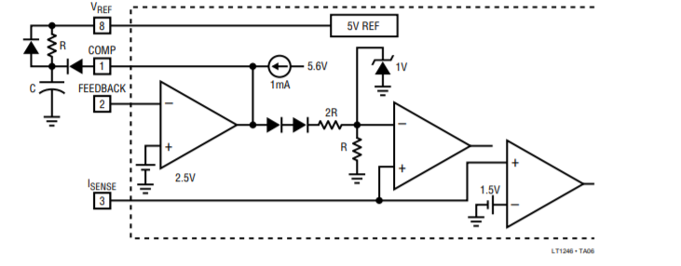

FigureXX: error amplifier of the “Lt1246”.

It has its own internal error amplifier, which has a reference voltage of 2.5 Volt, therefore, in order to regulate 15 volt output voltage, we need to divide that value to be equal to 2.5 volt by creating voltage divider network. Also it has a “RT/CT” pin that can be connected to an “RC” circuit to adjusting its ramp waveform frequency.

1. **Compensation network.**

First of all, all of the component that are connected to this network is end up at the pins which are “FB” and “COMP” both of are input to the some operational amplifiers inside the controller therefore the current passing through these components is not among the selection considerations. However, during the start-up, the voltage on the output can reach the 45 volt therefore, their rating may be at least that value to guarantee the safe operation because we don’t have any isolation on the feedback side.

**Voltage divider network:** This part is also included in compensation network it consists of two resistors which are 1k and 200 ohm. as we mention above, their current rating are not important. So, we choose “CF14JT200R” as 200 ohm and “PR02000201001JR500” as 1kohm.

**Compensation network:** The components that are related to that part is derived in the “compensator” section. So in here we are just sharing the products as round values of previously calculated numbers. However, since there is no power handling and regulating high voltages (i.e output capacitor of circuit) all the capacitors are chosen as “Ceramic” capacitors.

470nF capacitor :C0402C474K9PACTU

10nF capacitor :GRM155R71C103KA01J

100nF capacitor :C0402C102K5RACTU

270 ohm capacitor :CF14JT270R

30 ohm capacitor : CFR-25JB-52-30R

**F) Oscillator part.**

In the Oscillator part , choosing the component values as close as the founded values in the paper is really important because it determines our switching frequency. we have made this calculation using the given equations in the controller datasheet as below.

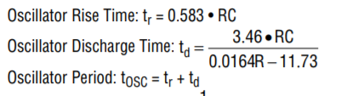

So, in our case Tosc=25 usec therefore equating this number to above formulas gives that

R=1kohm

And C=18.8 nF (choose it as 18nF)

So the chosen components are as below.

R (PR02000201001JR500)

C( **C0603C183K5RACTU)**